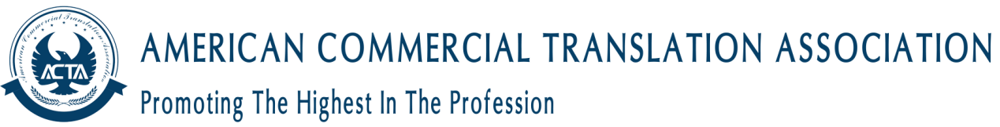

Student
Student is for anyone who is currently registered on a course leading to a graduate or post-graduate qualification.
Eligibility and Requirements
To be eligible for student membership, you need to meet the following criteria:
Attendance on a degree-level or post-graduate course
Please note that Student membership is for a limited period to match the length of the course. For example: if your course ends in September 2014, your student membership will expire at the end of the membership year on 30th April 2015.
Benefits
Student membership represents great value for money. Student membership gives you the opportunity to network with other translators and interpreters through our social media sites and regional, subject and language groups and networks.
All members receive the following benefits:
• ACTA Bulletin - ACTA's professional journal
• Discounted attendance at ACTA events including webinars
• Networking opportunities
• Help and advice in the members' area of the website
• Access to job adverts through ACTA Bulletin and the website
• Use of ACTA’s online CPD logging system in the members’ area of the website
• A legal helpline offering free advice on a range of legal matters
• Free use of a credit checking facility for US businesses
• Discounts on software and other services
• Representation on an international level
• Access to competitively priced specialist Professional Indemnity insurance
We hope that you will make the most of the benefits on offer and find them valuable at this stage in your career.
When applying, you will be asked pay the membership for the relevant quarter. Full details are included in the application pack.
Code of Professional Conduct
All members of the Institute are expected to uphold its Code of Professional Conduct. How to apply
Before we can send you the application documents, we need to ask you to register through our website. Please note that registering does not constitute a commitment to apply but ensures that we are able to provide you with fast and dedicated help and advice throughout the application process if you choose to proceed.
Registration
Please complete our registration form. All information will be handled in accordance with our privacy and data protection policies.
Fields marked with a * are required.
Email Address *
Confirm Email Address *
Password *
Confirm Password *
First Name(s) *
Surname *
Major *
Grade *
Date of Birth

Where Did You Hear About Us? *
Category *
Address
Address line
Town\City
County
Post Code
Country
Work Telephone
Home Telephone
Application Terms & Conditions *
Please tick below to confirm you have read and understood the Application Terms and Conditions
ACTA will contact you regarding your application/membership/ACTA monthly updates by email or phone. If you have a disability that requires ACTA to make reasonable adjustments to assist you, e.g. increased font sizes on forms, etc., please contact our Operations Manager, with your request at operationsmanager@acta.org.us

