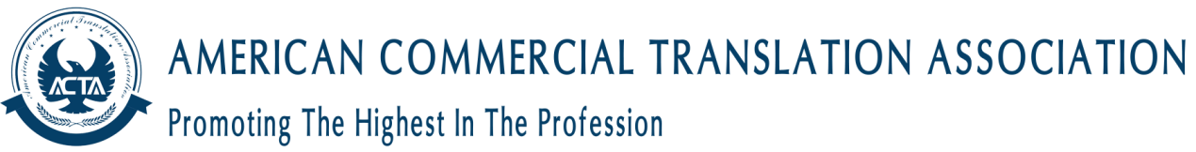

Individual Membership is available to translators and interpreters at every stage of their career, and to any individual who has a professional interest in translation or interpreting.
Translators and interpreters with a minimum of 1 year of relevant experience can apply for this type.
There are 3 sub-categories of this type: translator, interpreter and conference interpreter. Applicants can apply in one or more sub-category and can add a sub-category to their ACTA membership at any point.

Eligibility and Requirements
To be eligible for Associate (ACTA) membership, you need to meet the following criteria:
Experience - A minimum of 1 year of relevant professional experience in translation or interpreting
References - Recommendations regarding ability and good reputation
Applicants must provide a minimum of 2 professional references and 1 character reference. References should be from your main work providers. References must demonstrate a minimum of 1 year of relevant experience.
It is the applicant’s responsibility to submit the required references to ACTA. Referees must have known the applicant for at least 1 year. All references must be from different sources. References cannot be supplied by spouses, partners or family members. Applicants must provide their references on the appropriate ACTA reference forms wherever possible.

Registration
Please complete our registration form. All information will be handled in accordance with our privacy and data protection policies.
Fields marked with a * are required.
Email Address *
Confirm Email Address *
First Name(s) *
Surname *
Major *
Years of Practice *
Amount of Translation *
Where Did You Hear About Us? *
Category *
Address
Address line
Town\City
County
Post Code
Country
Work Telephone
Home Telephone
Application Terms & Conditions *
Please tick below to confirm you have read and understood the Application Terms and Conditions
ACTA will contact you regarding your application/membership/ACTA monthly updates by email or phone. If you have a disability that requires ACTA to make reasonable adjustments to assist you, e.g. increased font sizes on forms, etc., please contact our Operations Manager, with your request at operationsmanager@acta.org.us

