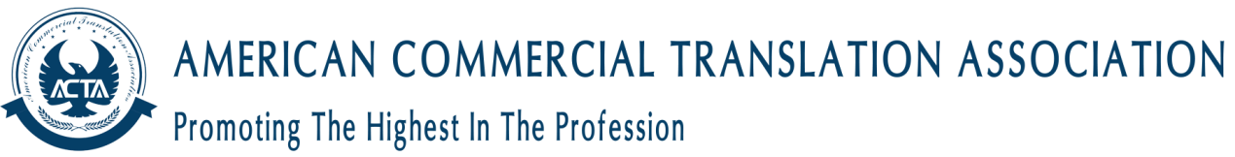
Corporate Membership is available to businesses and organizations that provide translation and/or interpreting services (LSPs, in-house translation departments, government or supra-governmental translation departments), universities that provide translation and/or interpreting qualifications, and any business or organization that has a professional interest in the translation or interpreting industry.
Language Services Business
Language Services Business is for businesses and organizations that provide translation and/or interpreting services.
Eligibility and Requirements
Eligibility - At least two years’ current trading as a business offering translation or interpreting services and employing translators or interpreters under a contract of services. If the business is incorporated or otherwise required to be registered, it must be registered with the appropriate authority.
It is the applicant’s responsibility to submit the required references to ACTA. Referees must have known the applicant for at least 1 year. All references must be from different sources. References cannot be supplied by spouses, partners or family members. Applicants must provide their references on the appropriate ACTA reference forms wherever possible.

Registration
Please complete our registration form. All information will be handled in accordance with our privacy and data protection policies.
Fields marked with a * are required.
Email Address *
Confirm Email Address *
Name of the Company (In English) *
Your Title *
Legal Person *
Major domain of Translation *
Years of Practice *
Amount of Translation *
Legal Person *
Number of Staff *
Website *
Working Address
Address line
Town\City
County
Post Code
Country
Work Telephone
Home Telephone
Application Terms & Conditions *
Please tick below to confirm you have read and understood the Application Terms and Conditions
ACTA will contact you regarding your application/membership/ACTA monthly updates by email or phone. If you have a disability that requires ACTA to make reasonable adjustments to assist you, e.g. increased font sizes on forms, etc., please contact our Operations Manager, with your request at operationsmanager@acta.org.us

